Experiment No: 02
Experiment Name : Experiment on basic signals

Objective:
- To learn plotting of different basic signals
Apparatus:
- Computer with MATLAB Software installed

Code And Figures:
clc;  clear all;  close all;  t = -6:1:6;  u(t == 1) = 2;  u(t != 1) = 1;  stem(t, u);  xlabel('Time (s)');  ylabel('U');  title('Unit Step Signal');  grid on; | 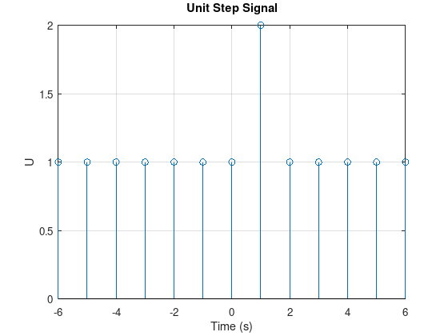
clc;  close all;  clear all;  t = -5:1:5;  u(t < 0) = 0;  u(t > 0) = 1;  stem(t, u, 'r');  xlabel('Time (s)');  ylabel('u(t)');  title('Unit Impulse Signal');  grid on; | 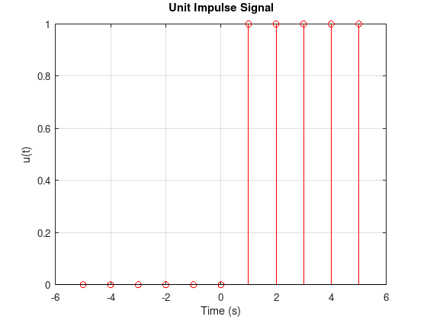
clc;  close all;  clear all;  t = -6:1:6;  r = 1:12;  for i = 1:length(t)  if t(i) >= 0  r(i) = t(i);  else  r(i) = 0;  end  end  stem(t, r, 'r');  xlabel('Time (s)');  ylabel('r(t)');  title('Ramp Signal');  grid on; | 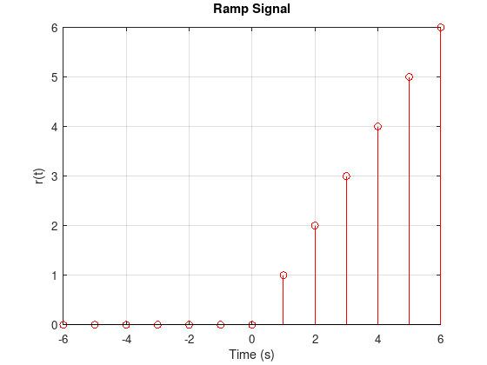
clc;  close all;  clear all;  t = -5:1:5;  y = t;  stem(t, y, 'r');  xlabel('Time (t)');  ylabel('y(t) = t');  title('Exponential Signal');  grid on; | 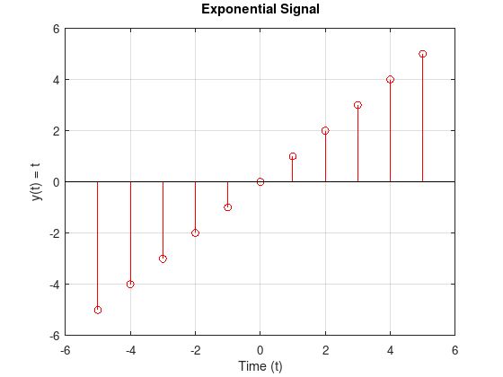

Discussion: In this lab, we explored basic signals such as the unit step, unit impulse, ramp, and exponential signals. The unit step signal models sudden changes, the unit impulse represents an instantaneous change at t=0, and the ramp signal shows a linear increase over time. The exponential signals demonstrated growth and decay, representing processes like population growth and radioactive decay. Using Octave, we visualized these signals to understand their behavior and applications in signal processing and system analysis.

